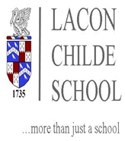

INFORMATION FOR PUPILS WHO TRAVEL ON SCHOOL TRANSPORT RUN BY
WORCESTERSHIRE COUNCIL (Bayton/Mamble/Clows Top/Far Forest/Frith common areas)

We have been advised that each year group will be required to travel in a zone on board all the school buses/minibuses. Pupils must occupy the same seat for each journey.
Year 7 | GREY
Year 8 | RED
Year 9 | BLUE
Year 10 | GREEN
Year 11 | ORANGE

The school have also advised that face masks should be worn on all transport.
Any queries, please contact Worcestershire Transport directly on 01905 765765.

24th August 2020

