 | MONDAY | TUESDAY | WEDNESDAY | THURSDAY | FRIDAY
LUNCH TIME | - Boys and girls dodgeball (ZT, MST) | - KS4 fitness (LB)  - Basketball (SA, MST) |  |  | - KS3 indoor cricket boys and girls (MST)  - Y10 DofE (RCB)
AFTER SCHOOL | - Hockey all years (LS, RC) | - Fixtures night  - Rounders club, all years, boys and girls (ZT)  - Tag rugby (SA) | - Girls football (LS)  - Running club (PH)  - Girls boxing (BB)  - Basketball (MST) | - KS3 girls fitness (SA, IM)  - Y9 DofE (RCB, ZT, KW, NR)  - Cricket all years (MST) | - Badminton all years (MST, ZT)
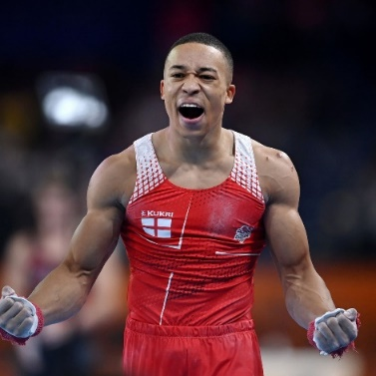
LACON CHILDE EXTRACURRICULAR
SUMMER 2023

