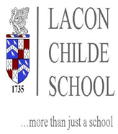

Minibus Information
The cost per pupil for the 2023/24 school year will be £750 (£250 termly), £651.75 for Year 11s. This is £3.95 per pupil daily. A £60.00 deposit is required to secure your child’s place on the bus. Following payments should be made on the first of each month via your ParentMail account or by standing order, in 10 equal monthly instalments of £69.00 from September to July.
To set up a standing order please use the following details:
Bank Name: Lloyds Bank plc
Account Name: Shropshire Gateway Educational Trust
Sort Code: 30 67 88
Account Number: 15371568
Please use your child’s surname as the reference.
Please note we cannot accept bookings when payment for previous minibus services are outstanding.
As the bus is subsidised by the school budget, pupils will be expected to pay for their seat for the academic year and no subsidy will be given for sickness or other absences. A bus pass will be issued after the first Standing Order payment has been received.

