1- Global atmospheric circulation helps to determine patterns of weather and climate. | 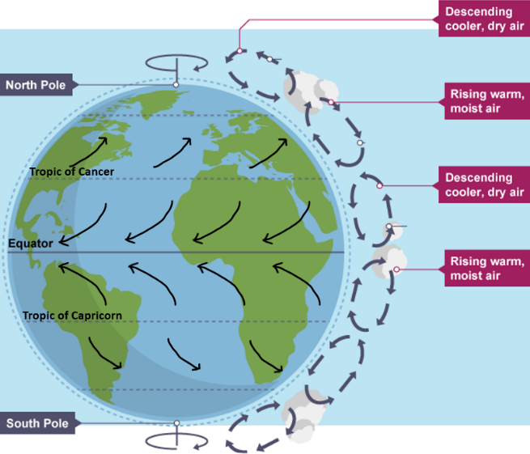  Global atmospheric circulation = the movement of air around the globe transporting heat from tropical to polar latitudes.  At the equator: At the equator temperatures are high as solar radiation is more intense. This means that evaporation occurs and moist air rises. Air pressure is low. As the air rises, the moisture condenses so clouds form. There is lots of rain. At the tropics: Air from the equator has moved towards this point. It has now cooled and dry. This means it is more dense so sinks. This creates high air pressure and little rainfall. Mid-latitudes: Warm air from the equator meets cold, dense air from the pole. The warm air rises. As it rises is becomes colder so clouds form. This leads to rainfall. At the poles: At the pole the temperatures are cold. This means that the air is denser, so it sinks and moves at towards lower latitudes as surface winds. Trade winds: Winds blow air over the surface from the tropics to the equator, from the west to the east. Westerlies: winds blow air across the surface from the tropics towards the poles Westerlies blow towards the poles.
2- Tropical storms (hurricanes, cyclones, typhoons) develop as a result of particular physical conditions.  An understanding of the relationship between tropical storms and general atmospheric circulation.  How climate change might affect the distribution, frequency and intensity of tropical storms. | 2A: A tropical storm = a low-pressure weather system with clouds that spiral around a central eye can carry heavy rain and winds and cause a storm surge. Global distribution of tropical storms: Between the Tropic of Cancer and Tropic of Capricorn. The highest numbers of tropical storms occur in the North Pacific  Causes of tropical storms and the sequence of their formation and development  - The surfaces temperature of the ocean reaches 27 ^{O} Celsius and evaporation occurs.  - The warm, moist air rises and then cools and condenses so clouds form leading to heavy rain. The clouds form the walls of the tropical storm.  - Some of the cooled air sinks back down through the centre of the clouds forming an eye where there is no rainfall.  - Air rushes in from outside of the storm system to replace the rising air, this creates strong winds.  - The storm rotates because of the spin of the earth (the Coriolis effect).  Tropical storms occur in the between the tropics because … high levels of solar radiation leading to rapid evaporation. In the northern hemisphere tropical storms move… towards the west. In the Southern hemisphere, tropical storms move … towards the east. This is due to… the different directions of surface winds in each hemisphere.
2B: Impact of climate change= air temperatures rise à sea temperatures rise à more areas are 27 degrees C or higher for more of the year. The distribution tropical storms: more areas will be vulnerable to tropical storms. Hurricane Catarina was the first hurricane to hit Brazil in 2004.
The frequency of tropical storms: has slightly increased. 10 out of the 13 most active years happened in last 20 years.
The intensity of tropical storms: increased in the last 20 years
3- Tropical storms have significant effects on people and the environment. | Case study: Typhoon Haiyan, November 2013. Affected the Philippines
 | Primary effects  - 6300 dead; Flooding with a 6m high storm surge –main cause of death  - Damage to Tacloban airport  - 1 million homes damaged.  - 30 000 fishing boats destroyed; Crops and power lines damaged in winds | Secondary effects  - Electrocutions due to electrical wires in water  - Malaria due to stagnant water attracting mosquitos.  - Looting and violence in Tacloban  - 6 million people lost their source of income – fishing/farming.  - >1 million homeless one yr 1 later  - Total costs $20billon
 | Immediate responses to Typhoon Haiyan  - 1600 evacuation centres set up.  - Military planes and helicopters used in the rescue and relief efforts.  - International governments and aid agencies came to help e.g. US aircraft carrier George Washington  - Aid agencies helped e.g. the Red Cross delivered basic food aid including rice, canned food and sugar. |  |  |  | Long-term responses to Typhoon Haiyan  - Cash for work programmes  - Thousands of homes built further from flood risk areas.  - More typhoon shelters built to help shelter people in any future evacuations.  - Roads and the Tacloban airport rebuilt.
How monitoring, prediction, protection, and planning reduces the effects of tropical storms.
Monitoring: = recording physical changes to help forecast when and where a tropical storm may occur. Ocean temperatures, wind speed and direction à used to predict à when a tropical storm may start, its strength and path.
Protection: = Actions taken before a hazard strikes to reduce its impact. Tropical storm shelters – raised off the ground, strong foundations and rooves, water collection system for drinking water, cover glass windows, keep trees cut back away from buildings, flood defences and sea walls.
Planning: = Actions taken before a disaster, so people know how to respond. Have risk maps and evacuation plans in place, emergency kits in houses, education about how to protect your home.
4- The UK is affected by a number of weather hazards | An overview of types of weather hazard experienced in the UK.  Heavy rainfall - flooding Snow and ice - injuries, closure of businesses and schools, roads closed, crops harmed Drought - lack of rain and crops die, hosepipe bans Heat waves - heat exhaustion, disruption to some transport e.g. rail lines buckling Strong Wind - uprooted trees, some damage to properties, airplane flights cancelled.
5 - Evidence that weather is becoming more extreme in the UK. | Temperatures are becoming more extreme – Top 10 warmest years are all from the last 2 decades.  Rainfall is becoming more intense – 7 of the 11 wettest years have occurred in the last 20 years.  Example of extreme weather events post 2000:  2003 – heatwave  2007 and 2009 – floods – north and central England.  2010 – Heavy snow – record low temperature in December.  2013/14 and 2015/16 – floods – in both south and north England.  2017 – strong winds  2018 – snow – Beast from the East  2019 – heat – record temperatures in July. 2020 – floods/wind
6- Extreme weather events in the UK have impacts on human activity. An example of a recent extreme weather event in the UK to illustrate… | Extreme weather - weather significantly different from the usual weather pattern and/or is dangerous.  Beast from the East 28th Feb-2nd March 2018
 | Causes - Cold air mass from Russia met Storm Emma from the Atlantic leading to colder temperatures and lots of snow. |  | How management strategies  Blizzards – weather warnings, gritting roads, emergency service planning  Heavy rainfall – reservoirs to store water, dredging, weather warnings
 | Social impacts = NHS cancelled operations; schools closed for up to 3 days. 16 people died. People stranded in cars/trains e.g. train near Dorset stranded overnight. |  | Economic impacts = Gas deficit as gas supplies ran low – some large factories reduced their operations. 1200 flights cancelled e.g. from Birmingham. Councils doubled the amount they usually spend on grit for roads. £1billion/day of losses for businesses forced to close. Farmers’ incomes fell as crops and livestock died
 | Environmental impacts = birds struggled to find food, loss of farm animals and crops
7- Climate change is the result of natural and human factors and has a range of effects. | Climate change = A long-term change in the earth's climate, especially a change due to an increase in the average atmospheric temperature.  Evidence for climate change from the Quaternary period to the present day  Ice cores, pollen analysis and tree rings give evidence of past climate.  Quaternary period = 2.6million years ago until the present day. The climate has varied over this time. Cold glacial periods lasting 100 000 years and warmer interglacial periods lasting approximately 10 000 years.  Last glacial period - ended about 10 000 years ago. Temperatures are continuing to rise.  Recent temperature rise – 1.2 degrees since the start of the industrial revolution
“Natural factors causing climate change ••
orbital changes - earth’s orbit can be more elliptical (egg shaped) so the amount of solar radiation decreases and the climate cools.
volcanic activity - in the short-term eruptions add ash and sulphur dioxide to the atmosphere which can cool the climate by reflecting the sun’s rays.
solar output - the sun sometimes emits more heat over cycles of 11 years and several hundred years although this doesn’t have a big impact.

•• Human factors causing climate change ••
Enhanced greenhouse effect - The increased warming to the earth’s climate created by greenhouse gases emitted by human activities.
Greenhouse gases - Gases which absorb heat and trap it in the earth’s atmosphere rather than letting it escape into space.
use of fossil fuels = emits greenhouse gases like carbon dioxide which trap more heat within the atmosphere.
agriculture = rice paddies and cows produce methane which is a greenhouse gas.
deforestation = deforestation means there are fewer trees taking in carbon dioxide through photosynthesis so the level of carbon dioxide in the atmosphere rises leading to an enhanced greenhouse effect
 | Overview of the effects of climate change on the environment  -Melting of glaciers and ice sheets e.g. Greenland = sea level rise - flooding e.g. Maldives à loss of coastal habitats, people are displaced  -Warmer seas = habitats change so species cannot survive e.g. coral bleaching  -Rainfall patters are changing e.g. more intense rainfall in the UK  -Biodiversity is changing - some species are moving to higher latitudes as temperatures become warmer. Some species are no longer able to survive in their habitats so may become extinct. |  |  | Overview of the effects of climate change on people  - Heat wave deaths  -Flooding from sea level rise or intense rainfall - deaths, damage to property  -Changes to farming - loss of crops in droughts, new species grown e.g. grapes in the UK  -Reduced farming output - malnutrition e.g. sub-Sahara Africa  -Damage from increasingly extreme weather e.g. hurricanes  -Political problems e.g. fighting over water, deciding who is responsible for the damage caused by climate change.
8- Managing climate change involves both mitigation (reducing causes) and adaptation (responding to change). | Mitigation = Actions taken to reduce the amount of climate change and therefore prevent risk to society  Alternative energy production - solar panels, wind turbines to reduce the amount of fossil fuels being burnt and the amount of carbon dioxide released.  Carbon capture - trapping carbon dioxide emitted by power stations, compressing it and storing it in rocks; planting trees -> more photosynthesis so more carbon dioxide taken in from the atmosphere;  International agreements - countries deciding to reduce carbon emissions e.g., 2015 Paris agreement
Adaptation = Actions taken to adjust to climate change to reduce and cope with damage.
Change in agricultural systems - farming crops that can survive in warmer climates e.g. soya beans and grapes in southern England, creating new varieties which can be drought resistant e.g. rice in India
Managing water supply - water metres to reduce water waste, rainwater collection, pumping water from aquifers, desalination of sea water.
Reducing risk from rising sea levels - building defences, modifying houses e.g., stilts in Bangladesh, creating shelters to cope with flooding.

