Key idea | Specification content
1. Ecosystems exist at a range of scales and involve the interaction between biotic and abiotic components. | Section A  Ecosystem: A community of plants and animals that interact with each other and their physical environment.  Biotic: living things. Abiotic: non living things  Producer: An organism that uses energy from the sun to create its own food through photosynthesis  Consumer: An organism that eats other things in order to get energy  Decomposer: An organism that breaks down dead material to get energy e.g. fungi and bacteria. Decomposition releases nutrients into the soil that are taken up by plants.  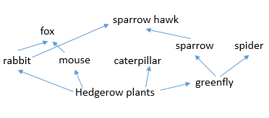  An example of a small scale UK ecosystem: hedgerow  Food chain: The connections between different organisms that rely on one another as their source of food. Hedgerow food chain = blackberry à mouse à fox  Food web: a complex hierarchy of plants and animals relying on each other for food.  *Decomposers operate at all levels in the food chain/web.*  Nutrient cycling – the processes where organisms extract minerals from the soil or water, and then pass them through a food chain until they eventually return to the soil and water.
Section B
The balance between components
Components in an ecosystem = the abiotic and biotic things in the ecosystem e.g. animals, plants, rainfall, soils.
The components interact with each other e.g … the plants use the soil to obtain nutrients then when the plant dies its leaves decompose and the nutrients return to the soil.
The impact on the ecosystem of changing one component
Components are interdependent =every part of an ecosystem is linked. A change to one component will have an impact upon the rest of the ecosystem.
Hedgerow example: disease affects the population of foxes à fewer rabbits and mice eaten à number of rabbits and mice increases àmore animals eating hedgerow plants à amount of hedgerow plants decreases à population of mice and rabbits declines.
Section C.
An overview of the distribution and characteristics of large-scale natural global ecosystems.
Large scale ecosystem: Very large ecological areas on the earth’s surface (or biomes), with fauna and flora (animals and plants) adapted to the environment.
Ecosystem | Location | Climate | Vegetation
Polar | North and south pole | Very cold winters and short cold summers, little precipitation. | 2 month growing season, little vegetation mainly mosses.
Tundra | 60 to 70 degrees north | Very cold winters, short summers, little rainfall | Permafrost. Mosses, grasses, low shrubs.
Temperate deciduous woodland | 50 degrees north of the equator | 4 seasons, warm summers, mild winter, rain all year | Deciduous trees = lose leaves in winter to retain moisture.
Mediterranean | 40 to 45 degrees north of the equator | Warm wet winters, hot dry summers | Shrubs and small trees e.g. olive, lemons and oranges.
Temperate grasslands | 30 to 40 degrees north of the equator. Inland. | less rainfall but seasonal temperature variation, warm summers, cold winters. | Grasses no trees e.g. Central USA
Hot desert | 30 degrees north and south of the equator | Little precipitation, very hot it the day, cold at night. | Few plants, all adapted to dry conditions
Savannah grasslands | 15 to 30 degrees north and south of the equator | Hot all year. Wet and dry seasons but low total rainfall | Grasses with some scattered trees.
Tropical rainforest | Close to the equator | Hot and with high rainfall all year. | Dense, layered forests

2. Tropical rainforest  ecosystems have a range of  distinctive characteristics. | 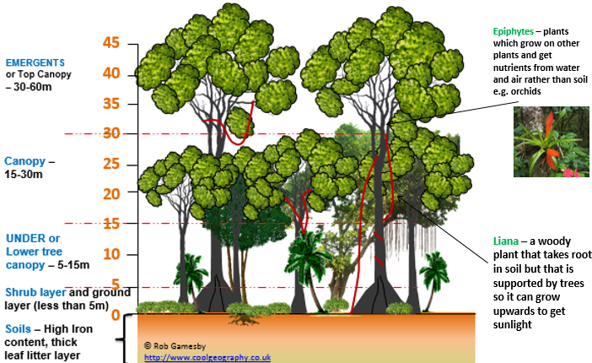  Section A: The physical characteristics of the Amazon rainforest  Climate – Warm all year between 26 and 28 ^{O} C. Rainfall all year. Total 2145mm  Soils – very thin and low in nutrients as the many plants take up the nutrients quickly. High iron content as rainfall removes nutrients.  Plants – dense vegetation as the climate is perfect for photosynthesis through the year. Layers of vegetation. Evergreen trees as the temperature range is so small so leaves can be grown easily all year round.  Animals - There are lots of animal species as the vegetation layers create a range of habits and the climate is able to produce lots of vegetation through the year as food.
Section B: The interdependence of climate, water, soils, plants, animals and people.
Soil depends upon the climate –warm and humid conditions allow rapid decomposition to create soils.
Soil depends upon plants – rapid uptake of nutrients and water, dead leaves decompose and become soil Plants depend upon the climate – determines the amount of photosynthesis, determine the adaptations
Plants depend upon animals – eating them, distributing seeds
Animals depend upon plants – provide habitats and food, animals adapt to live in a forest
Animals depend upon the climate – animals adapt to the climate.
Section C: How plants and animals adapt to the physical conditions
Adaptation: Features and behaviours that help an organism survive in its environment
Plant adaptations
Buttress roots – wide roots growing out of the ground to support tall emergent layer trees in shallow soils
Waxy leaves with drip-tips – rain can run off without damaging the plant or creating standing water for fungi to grow in
Climbing plants – so they can climb up high to reach more sunlight for photosynthesis e.g. vines
Animal adaptations
Gliding – flaps of skin so they can glide between trees and avoid the forest floor where there are predators e.g. flying squirrel.
Camouflaged –so animals can hide in the vegetation e.g. leaf-tailed gecko
Nocturnal-sleep in the day and are active at night when it is cooler, helping them save energy e.g. sloths
Swimming – can cross the many river channels to find new areas to hunt in e.g. jaguars.
Section D: Issues related to biodiversity.
Biodiversity = number of plants and animal species living in an area
Rainforests have a high biodiversity – over 50% of the world’s species live in rainforests that cover only 7% of the world’s land.
Why?...The hot, wet conditions make the rainforest very productive as photosynthesis occurs all year à large numbers of plants grow à species adapt to compete for light à layers of vegetation à animals evolve to become very specialise (particular habitat and food source à many animals can lives in the same area.
Issues…Biodiversity is useful for humans as it provides medicines and food. Rainforest biodiversity is underthreat due to deforestation and climate change.
3. Deforestation has economic  and environmental impacts  3. Deforestation has economic  and environmental impacts | Section A: Changing rates of deforestation  Rate of deforestation today = 300 000 km² per year  Change to deforestation rates over time = the global deforestation rate has slowed, Brazil’s deforestation rate has decreased significantly. Some areas including the Indonesia, Borneo and Nigeria have increased rates.
Section B: Causes of deforestation in the Amazon: Since 1978, 750 000 km² has been destroyed by deforestation.

Subsistence farming – A type of agriculture producing food and materials for the benefit only of the farmer and his family. Small areas of forest cleared and the trees burnt, allowed to regrow after 5-10 years. e.g. in indigenous communities in Jau.
Commercial farming – Farming to sell produce for a profit to retailers or food processing companies soya beans and cattle e.g. cattle ranching is responsible for 70% of the Amazon’s deforestation
Logging – The business of cutting down trees and transporting the logs to sawmills. Often done illegally.
Settlement – Brazil’s population is increasing. Brazilian government offered poorer people in cities land in the rainforest e.g. Manaus
Road building – leads to increased illegal logging as more areas of the rainforest are made accessible.
Mineral extraction – The removal of solid mineral resources from the earth. Leads to roads and settlement. e.g. Carajas, the world’s largest iron ore mine.
Energy development – clearing land for hydro-electric power dams Also leads to more roads and settlement e.g. Belo Monte dam.
Section C: Impacts of deforestation in the Amazon
- Soil erosion – trees removed - rainfall washes away nutrients through erosion and leaching - soil becomes infertile so farming stops - forest cannot regrow
- Global warming – trees burnt down - CO² released + fewer trees - less CO² taken in through photosynthesis - more CO² trapping heat in the earth’s atmosphere
- Habitats lost - biodiversity decreases - giant anteater and Amazonian manatee become endangered
- Economic development - Income for Brazil - $6.9billion from cattle trade. Employment - 7000 people employed by Carajas.
4. Tropical rainforests need  to be managed to be  sustainable. | Section A  Value of tropical rainforests to the environment.  - Trees lots of carbon helping to limit global warming  - Regulates the water cycle by storing and transferring water – deforestation would lead to flooding and more variations in rainfall.  - Habitats - over 50% of all species are found in rainforests  Value of tropical rainforests to people.  - Home to indigenous communities  - Tourism  - New medical resources using plant based chemicals
Section B
Sustainable management – using the rainforest in a way that doesn’t damage it so the forest will last and meet the needs to society today and in the future.
Selective logging – The cutting out of trees which are mature or inferior, so the rest of the trees can continue to grow. Some trees remain so the soil is protected and there is still some habitat left.
Replanting- replacing habitats that have been destroyed
Conservation– Managing the environment in order to preserve, protect or restore it. E.g. Jau National Park, no new development, rangers to stop poaching and illegal logging.
Education - Charities raising awareness about the need to protect the rainforest so they’re more likely to buy sustainably sourced products and educating local people in less damaging ways to use the rainforest e.g. ecotourism, sustainable logging.
Ecotourism - Responsible travel to natural areas that conserves the environment, supports local people, and may involve education. It is usually carried out in small groups and has minimal impact on the local ecosystem e.g. Mashpi ecotourism lodge in Ecuador.
International agreements about the use of tropical hardwoods – agreements between countries to protect the rainforest e.g. debt for conservation swaps, international standards for timer e.g. Forest Stewardship Council mark to show that the timber is sustainably sourced.
Debt reduction. Countries are relieved of some of their debt in return for protecting their rainforests. E.g. USA cancelled $25million of Peru’s debt in return for Peru spending some of the money on conserving the Amazon and the Amazon river dolphin.

Cold environments (polar and tundra) have a  range of distinctive characteristics. | The physical characteristics =  Polar:  - Winter temperatures -50c.  - Low precipitation  - Soil = Permafrost – large areas permanently frozen.  - Plants = mosses and lichens at edges of area.  - Animals = polar bears, penguins.  Tundra:  - Less extreme climate. Temperatures as low as -20c.  - Quite warm in brief summers.  - Precipitation (snow) can be high in coastal regions.  - Soil = permafrost but close to the surface will melt in summer. Will become waterlogged. Infertile due to the water removing the nutrients.  - Plants = low growing flowering plants, e.g. bearberry, low bushes and small trees.  - Animals = Variety of animals e.g. Arctic fox, midges.
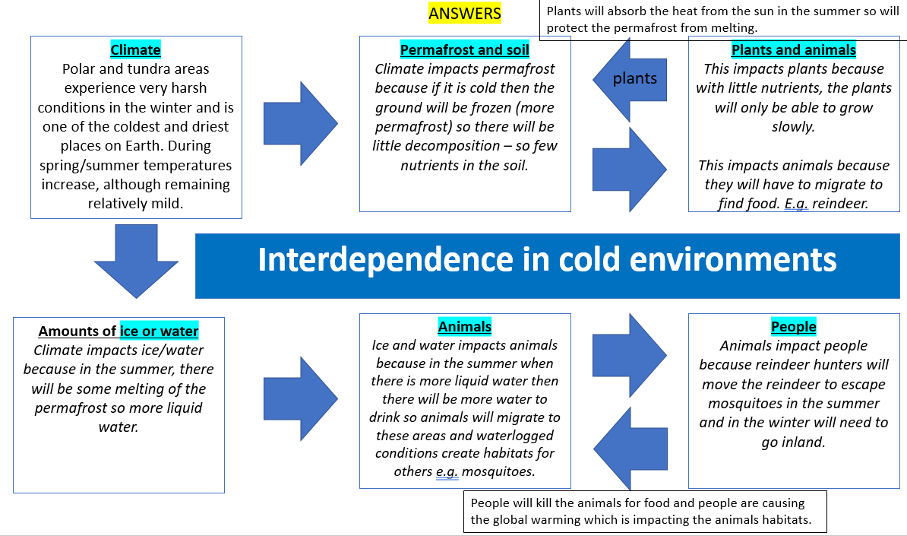
The interdependence of climate, permafrost, soils, plants, animals and people =

How has climate change impacted on interdependence?
- Melting of permafrost exposes topsoil to erosion and creates huge lakes, altering habitats.
- Mismatch between the growing season of plants and animals habits – e.g. in Greenland plants now grow earlier in the year but the caribou have not changed their migration.
- Species are moving northwards as the climate warms leading to conflict between animals e.g. red fox vs Arctic fox.
How plants adapted to the physical conditions =
- Low growing to protect from wind.
- Leaves are small to limit moisture lost.
- Shallow roots because of the permafrost.

How are animals adapted to the physical conditions =
- Thick fur so isolated from the cold.
- Hibernate to conserve energy during the time when there is little food.
- Birds migrate to warmer areas in the winter.
Issues related to biodiversity =
- Climate Change – temperatures warmer – loss of biodiversity as some species die. But some species like Salmon, might increase.
- Wildfires – higher temperatures and drier conditions – destroy vegetation and disturb animals natural cycles e.g. breeding.
- Human activity – e.g. oil exploration, industrial fishing, tourism – threat to ecosystems.
Development of cold environments creates  opportunities and challenges. | Case study = Svalbard  Development opportunities:  - mineral extraction =  Environmental groups are against mining in Svalbard because coal is a source of greenhouse gases – causing climate change. In 2014 a new mine opened – they had to build a road over a glacier. Mining coal has been a major employment in Svalbard – around 300 employed.  - energy =  Svalbard has lots of coal. Longyearbyen is Norway’s only coal fired power station and supplies all of Svalbard’s energy. Environmentalists think the coal power station should be shut down and geothermal energy used instead because Svalbard is close to the Mid-Atlantic ridge. Other future renewable energy options in Svalbard include: solar power (because Svalbard gets 24 hours of sunshine in the summer) and wind power (because it frequently has strong winds).  - fishing and tourism =  Tourism is growing in Svalbard, with over 150,000 tourists visiting in 2019. Tourism employed over 4000 people in 2019 in accommodation and food services. The harbour in Longyearbyen has been enlarged to cope with the increased number and size of cruise ships. There are 150 species of fish in the Barents Sea, including cod and herring. The Barents sea is an important breeding ground for fish. Fishing in the Barents sea is controlled and monitored by Norway and Russia to ensure fishing is sustainable. Tourists travel from Europe and North America mainly to visit the natural environment like glaciers and sea the wildlife like polar bears.
Challenges of developing:
- extreme temperature = -30 degrees Celsius in winter. It is dangerous to work outside. People have to dress warmly.
- Inaccessibility = Svalbard can only be reached by plane or ship. They only have limited transport including 1 airport that can have international flights, 50km of road.
- provision of buildings and infrastructure = Water and sewage pipes can’t go under the ground like in the UK because of the permafrost. Constructing buildings includes methods like using deep piles sunk into the permafrost, putting roads on a gravel permafrost. Making buildings is difficult because it is very cold and during the winter there is little light.
Cold environments are at risk from economic  development. | The value of cold environments as wilderness areas =  Wilderness = wild and unspoiled area unaffected by human activity.  Wilderness areas should be protected because…  - They are easily damaged by economic activities such as mining and tourism because the plants grow slowly so recovery takes decades.  - They are important outdoor laboratories for scientific research.  - Rare animals and plants need to be protected.
Cold environments are at risk from economic  development. | 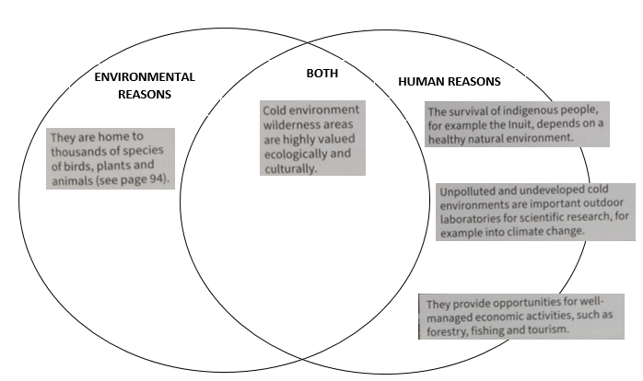  Why these fragile environments should be protected =
Cold environments are at risk from economic  development. | Strategies used to balance the needs of economic development and conservation in cold environments  - use of technology  In 1974 the Trans-Alaska pipeline was opened to move oil from Prudoe Bay in the North of Alaska, to Valdez in the south. Technological solutions were put in place to ensure that the pipeline could work.  One technological solution was to raise the pipeline above the ground so that the hot oil (49 degrees Celsius) does not melt the permafrost.  Another solution is an automatic system that stops the flow of oil if there is an earthquake.  A final technological solution is to raise the pipeline to allow large herds of animals like caribou to still follow their migration patterns.  - role of governments  The USA created the National Environmental Policy Act to ensure companies that extract and transport oil also protect the natural environment and recognise the rights of Alaska Native people.  The US government created the Western Arctic Reserve – a 9 million hectare protected wilderness area for caribou, birds, musk ox, wolves and polar bears.  The National Oceanic and Atmospheric Administration oversee sustainable fishing and protect marine habitats.  - international agreements  The Antarctic Treaty was created in 1961 to protect the natural environment of Antarctica and to stop countries claiming the land.  The Antarctic Treaty prevents economic development in Antarctica like mining to extract minerals.  The Antarctic Treaty encourages shared scientific research – mostly into climate change.  The Treaty controls tourism and minimises people disturbing the wildlife.  - conservation groups.  The WWF (World Wildlife Fund) is a conservation group that works with local communities to manage ecosystems like the Beaufort Sea. The WWF supports scientific research to protect species like polar bears. The WWF works with oil companies, local Inuit organisations and government regulators to plan for a sustainable future.

