1. Landscapes of the UK | 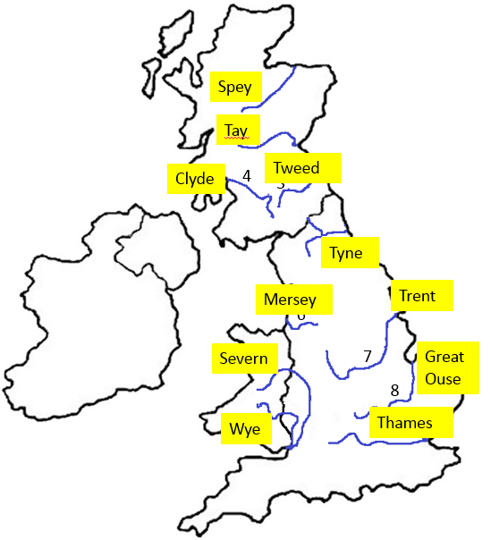  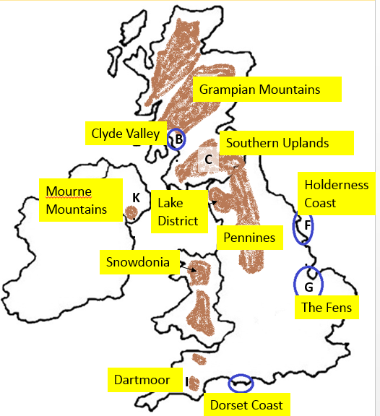  Rivers 100% Sheet 1
2. The shape of river valleys  change as rivers flow  downstream | Section A  Fluvial processes = erosion, transportation and deposition  Processes of erosion in a river – HAAS  Hydraulic Action - the force of the water traps air in cracks in the river beds, causing pieces to break away.  Abrasion - Rocks carried by the river hit the bed and banks causing it to wear away  Attrition - Rocks carried by the river smash together and break into smaller and rounder sediment.  Solution - Soluble particles are dissolved into the river.  Vertical erosion – ↓downward erosion that deepens the channel, this is the main direction of erosion in the upper course.  Lateral erosion – ↔ horizontal erosion that widens the channel, this is the main direction of erosion in the lower course.  Section B  Bedload – the material carried by a river  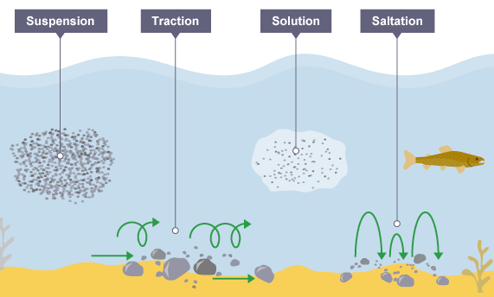  Processes of transportation in a river - TSSS  Transportation- carrying material  Traction - The rolling of boulders and pebbles along the river bed.  Saltation -Particles bouncing along the river bed.  Suspension - Fine material held in the water while the water is moving.  Solution - Soluble particles are dissolved into the river and carried downstream.  Process of deposition  Deposition – when a river drops the material it has been transporting.  Why?- at meanders, the mouth and in shallow water the river’s velocity slows à the river doesn’t have the energy needed to transport material à large materials are deposited first as they are heaviest so need the most energy to transport à if the river becomes even slower small materials are deposited too.  Section C  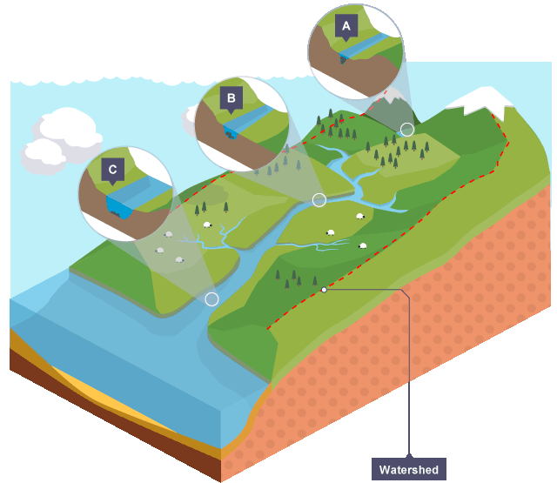  The long profile – the line of the river from the source to the mouth  The cross profile – a cross section of the river’s channel and/or valley.  Long profile in the upper course – steep  Long profile in the lower course - gentle  Cross profile in the upper course – narrow and shallow channel with a V shaped valley  Cross profile in the lower course – wide and deep channel with an almost flat valley floor.
3. Distinctive fluvial landforms  result from different physical  processes.  3. Distinctive fluvial landforms  result from different physical  processes.  Continued …. | 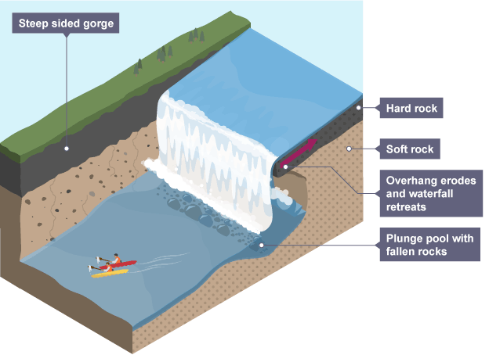  Section A Characteristics and formation of landforms resulting from erosion  Waterfall.  When water flows over a step in the landscape, usually when a river meets an area of soft rock after flowing over harder rock.  Formation  - A river flows over hard and then soft rock.  - Soft rock erodes away more rapidly à a step in the landscape forms.  - The falling water erodes the base of the waterfall through hydraulic action à a plunge pool forms.  - The falling water splashes backwards onto the soft rock à an undercut with an overhang above forms.  - The undercut grows overtime à the overhang becomes too large to remain unsupported à the overhang collapses à the waterfall retreats upstream creating a gorge.  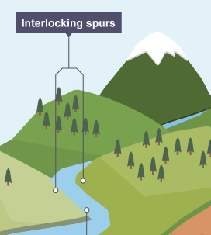  Section B  Interlocking spurs  A series of hills on alternate sides of a valley around which a river weaves.  Formation  - Vertical erosion occurs in the upper course but very little lateral erosion takes placeà the river cannot erode the hillsides  - The river weaves around hillsides as it flows downstream à hillsides = interlocking spurs  Section C starts on the next page.  Section C Characteristics and formation of landforms resulting from erosion and deposition  Meanders - A pronounced bend in a river.  Ox-bow lakes - An arc-shaped lake which has been cut off from a meandering river.  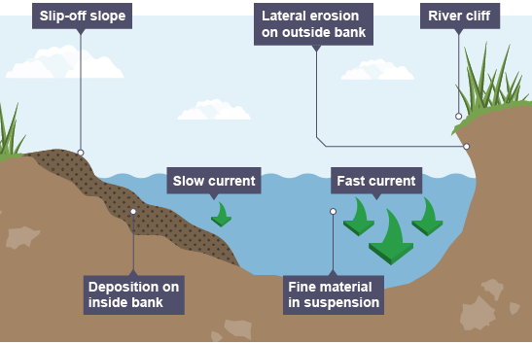  Formation  - At a curve in a river, the water on the outside of the bend has a higher velocity.  - More erosion occurs on the outside bends à creates a river cliff and narrows the meander neck  - The velocity is slower on the inside bend àdeposition occurs à slip off slope is created à a meander with an asymmetrical cross section is formed.  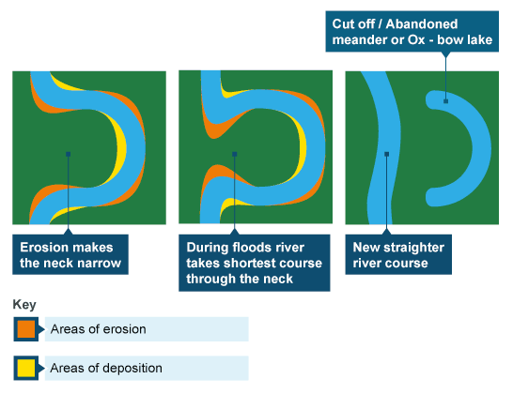  - Erosion continues at the outside bends of a meander à overtime the neck of the meander becomes narrower  - In a flood the water cuts through the neck à less water flows around the loop à the velocity is lower  - Deposition occurs in the meander loop à it is cut-off to form an ox-bow lake while the river flows in a straight path.  Floodplain - The wide and flat area either side of a river channel in the lower course, which is sometimes flooded.  Formation  - In the lower course the river erode laterally à interlocking spurs are removed to create a flat valley.  - In a flood material is transported out of the river channel à the flood water has a low velocity à material is deposited  - Over many floods layers of sediment build up à flat floodplains form either side of the river channel  Characteristics and formation of landforms resulting from deposition  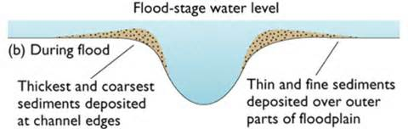  Levees - Bank of sediment along the bank of a river (natural or artificial).  Formation  - In a flood, material is transported out of the river channel.  - The floodwater has a low velocity à A low velocity also means less energy to move objects à large material is deposited close to the channel and smaller material further away.  - Over time, layers of sediment build up to create banks either side of the channel  Estuary - the tidal mouth of a river where it meets the sea; wide banks of deposited mud are exposed at low tide.  Formation  - The river flows downstream carrying sediment  - At high tide the sea enters the river à the river velocity slows à bedload is deposited towards the edges of the river channel  - Large mud flats build up on the edges of the river channel and are visible at low tide.

