Coasts 100% sheet

Key idea | Specification content
The coast is shaped by a number of physical  processes. | Coast = where the land meets the sea.  Wave are formed by the wind blowing over the sea.  Fetch = The distance the wind blows across the sea.  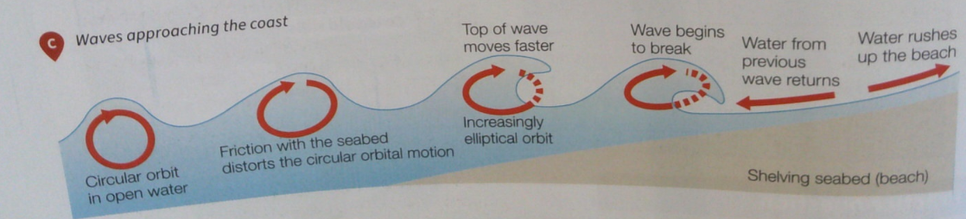  Constructive waves = Low waves that carry and deposit large amounts of material to ‘construct’ beaches.  Destructive waves = Steeper waves that have a powerful backwash which removes material from the beach.
  Wave characteristic | Constructive | Destructive
  Wave height | Low | High and steep
  Type of wave break (spilling or plunging) | Spilling | Plunging
  Strength of swash | Powerful swash | Weak swash
  Strength of backwash | Weak backwash | Powerful backwash
  Net beach sediment (gain or loss) | Gain – waves carry and deposit large amounts of sand and pebbles making a beach more extensive. | Loss – sand and pebbles removed so beach destroyed
The coast is shaped by a number of physical  processes. | Coastal processes:  - Weathering = The breakdown of rocks in their original place.  Mechanical weathering = break up of rocks and piles of rock fragments (scree) is found at the bottom of the cliff.  Chemical weathering = Rainwater, which is slightly acidic, very slowly dissolves certain types of rocks and minerals.  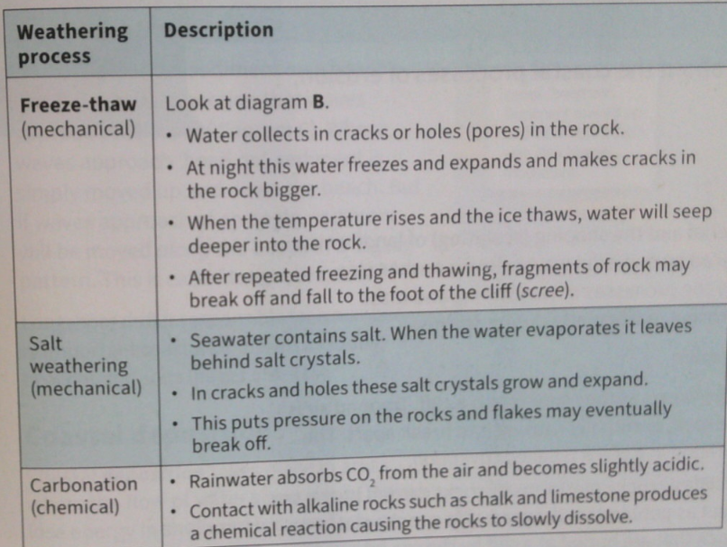  - Mass movement = The downward movement of material due to gravity.  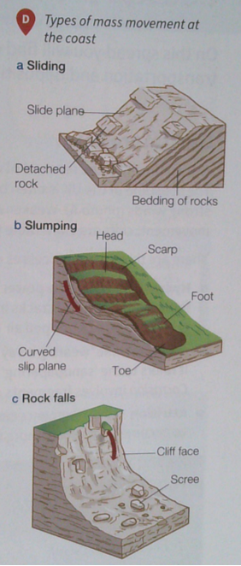  Sliding = Large blocks of rock slide down the cliff as a landslide. It is often caused by heavy rainfall or earthquakes.  Slumping = Saturated or weak rock, e.g. clay, collapse. Also known as slipping.  Rock fall = Fragments of rock break away from the cliff face because of freeze-thaw weathering. This creates scree at the bottom of the cliff.  - Erosion = waves or rivers gradually wear away the rocks, cliffs/ river banks.  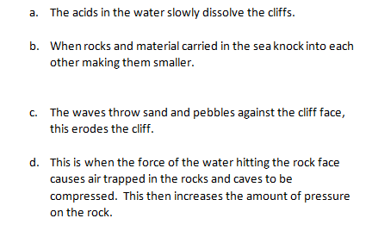  A = Solution  B = Attrition  C = Abrasion  D = Hydraulic Action/Power  - Transportation – longshore drift  Traction = Large pebbles dragged along the seabed.  Saltation = A hopping or bouncing motion of particles which are too heavy to be suspended.  Suspension = Particles carried within the water. Can make the water look dirty and ‘murky.’  Solution = The transport of dissolved rock. These are invisible to the eye.  Longshore drift is the transport of sediment along a stretch of coastline caused by waves approaching the beach at an angle.  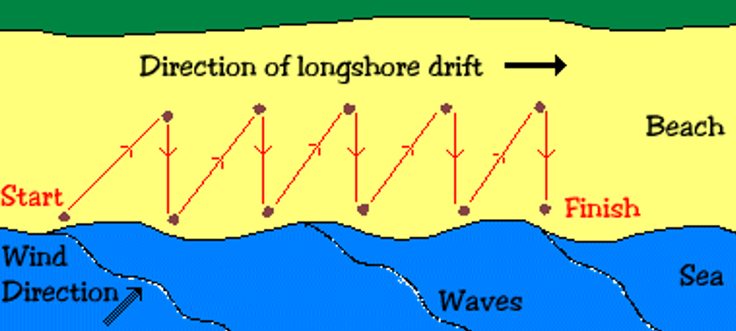  Swash  Backwash  Prevailing  - Deposition – Material carried by the waves or the river will be dropped, building up over time to create new land. ​Why does this happen?  - Water loses energy e.g. because it is in a sheltered area.  - So it is unable to carry the material.  - So the material is dropped.
Distinctive coastal landforms are the result of  rock type, structure and physical processes. | How does geological structure and rock type influence coastal forms?  Geological structure – the arrangement of rocks, including folding and faulting. For example, faults are lines of weakness in rocks and will mean erosion will occur faster.​  Rock type – some rocks are more resistant to erosion e.g. granite and chalk are harder rocks than sand and clay.
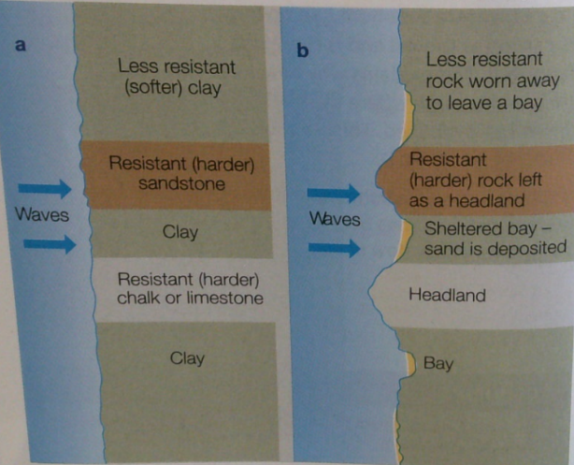
Characteristics and formation of landforms resulting from erosion:
- Headlands and bays
Headland = a piece of land that projects (sticks out) from a coastline into the sea.​
Bay = a broad coastal inlet often with a beach.

- Cliffs and wave cut platforms
Cliff = A steep high rock face formed by weathering and erosion.
Step 2

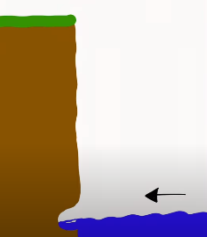
Step 1

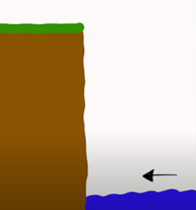

Step 3
Step 5

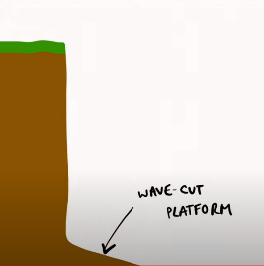
Step 4
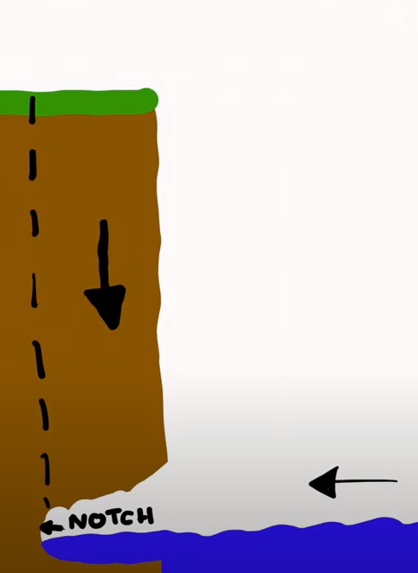

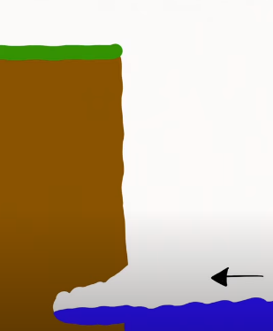

Step 1 – Crack in cliff is made larger with erosion – particularly hydraulic power and abrasion.
Step 2 – The crack gets wider until it creates a notch in the cliff (an indentation).
Step 3 – The notch gets even larger due to erosion, which undercuts the cliff above.
Step 4 – The overlying cliff is now not supported so will eventually collapse.
Step 5 – When the cliff above collapses, this creates a wave cut platform – a gently sloping rocky platform which is smooth, with rock pools.

- Caves, arches and stacks and stumps

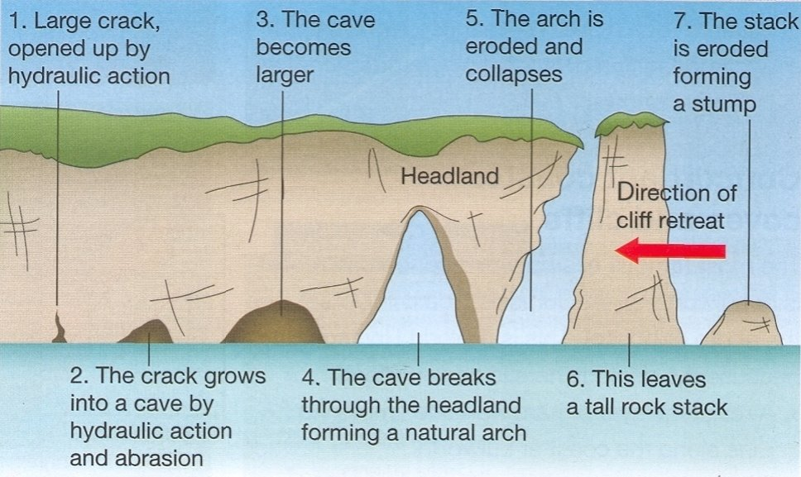
Characteristics and formation of landforms resulting from deposition:
- Beaches
Beaches are areas of lots of sand or shingle (pebbles).​
The wind blows over the water, forming waves.​ When waves are created they erode the cliff/headland. This is because the waves are tall and have a short wavelength. These waves are called destructive waves. The waves erode the headland by hydraulic action/power and abrasion. The eroded material is transported mainly by suspension and saltation.
When the waves enter the sheltered area of the bay they become constructive waves. These are low in height and long in wavelength.​ These low energy waves carry the eroded material up the beach in their swash where it is deposited to form a beach. The backwash of the waves is weak because the slope of the beach is gentle.

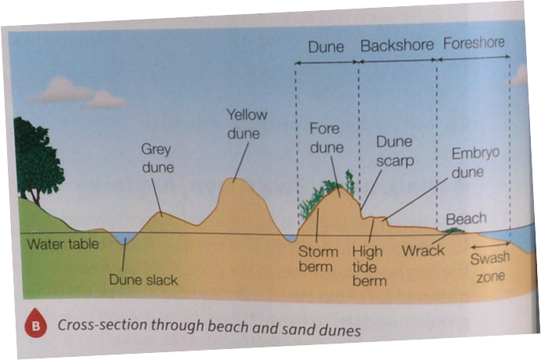
- Sand dunes
Wind moves sand along the beach until it encounters an obstacle like a piece of driftwood. This slows down the wind and deposits the sand, which will build up around these obstacles. This creates small sand dunes called Embryo dunes. They are right next to the beach and are the youngest dunes. The next dune inland is called the Fore Dune. This is where you will find salt tolerant vegetation e.g. Lyme Grass. Further inland, the first ridge of dunes are called Yellow dunes. Here you will find vegetation like Marram grass which has long roots to find water and the roots bind the sand together helping to stabilise it. They are called Yellow dunes because of the colour of the sand which makes them. Even further inland there are Grey dunes. There is more vegetation here because it is sheltered and it is not as salty, so more vegetation species grow e.g. Dewberry. Rotting vegetation adds organic matter, making it more fertile. Grey dunes are fixed and will not be destroyed unlike the other dunes, which could move or be destroyed by storm waves. Finally, Dune Slacks are depressions (holes) formed by the wind and ponds may form in them.

- Spits
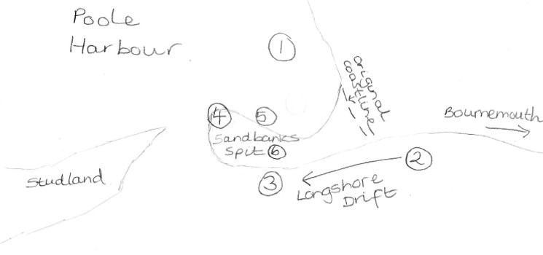
Definition = Spits are long narrow ridges of sand and shingle stretching out from the coast that can develop a hook or curved appearance. ​
1. Spits form at sharp bends in the coastline, such as when the coastline changes direction because of a river mouth. Sandbanks spit has developed across the entrance to Poole Harbour, in Dorset. ​
2. Longshore drift usually transports sand in the direction of the prevailing wind. ​
3. Longshore drift continues to move material past the end of the land, depositing it in the sea, extending the beach. ​
4. The spit becomes hooked or recurved due to a short-term change in wind direction or current.​
5. Behind the spit, a sheltered area of saltwater marshes and mudflats forms, which is covered by the sea at high tide. ​
6. Over time, the spit will become a stable land such as Sandbanks, where expensive houses are now built. ​

- Bars
Bar = Where a spit grows across a bay, a bay bar can eventually enclose the bay to create a lagoon (freshwater lake).
Offshore bar = Forms out to sea.​ When waves approach a gently sloping coast sediment is deposited due to friction with the seabed.​ The build-up of sediment offshore causes waves to break some distance from the coast.
Barrier beach = Some offshore bars can be driven onshore by rising sea levels.​

Jurassic Coast - An example of a section of coastline in the UK. Parts of Devon and Dorset, Southwest England.

Headland and Bay example | Lulworth Cove
Cliffs and wave cut platform example | Kimmerage Bay
Beach example | Swanage Bay Beach
Caves, Arches, Stacks, Stumps example | Old Harry Rock
Sand Dunes example | Studland
Spit example | Sandbanks
Bar example | Chesil Beach

Different management strategies can be used  to protect coastlines from the effects of physical  processes. | The costs and benefits of the following management strategies:  • hard engineering – Using artificial structures such as sea walls to control natural processes.  • soft engineering – Less intrusive more environmentally friendly methods of managing the coast which work with natural processes to protect the coast.​
  Name of strategy and description​ | Explanation of how it reduces erosion​ | Cost​ | Advantage X 2​ | Disadvantage X 2​ | Example on the Jurassic coast​
  Sea wall – concrete or rock barrier against the sea placed at the foot of cliffs or at the top of a beach.​ | Often has a curved surface at the top to reflect the waves back into the sea.​ | £5000-10,000 per metre​ | Effective at stopping erosion.  Walkway for people to walk on. | Look unnatural.  Very expensive and high cost to maintain | Lyme Regis​
  Groynes – timber or rock structures built out to sea at right angles from the coast.​ | They trap sediment being moved by longshore drift to enlarge the beach and protect the land behind from the waves.​ | Timber = £150,000 each (spaced every 200 metres along the coast)​ | ​Wider beach popular with tourists = economy.  Less expensive. | ​Interrupt longshore drift so stop material going along coast, causing erosion elsewhere.  Unnatural and unattractive. | Swanage Bay beach​
  Rock Armour – Piles of large boulders dumped at the foot of a cliff.​ | The rocks forces waves to break, absorbing the energy and protecting the cliffs from erosion.​ | £200,000  per 100 m​ | ​Relatively cheap.  Used for fishing = economy and leisure. | ​Expensive to transport.  Often do not fit with local geology. | Lyme Regis​
  Gabions – Wire cages filled with rocks at the edge of the coast.​ | Stop the waves eroding the cliff by absorbing the power of the waves and give the cliff support to make it more stable. ​ | £50,000 per 100 m​ | Cheap.  Improve drainage of cliffs. | ​Unattractive.  Cages only last 5-10 years before they rust. | Durlston Bay​
  Name of strategy and description​ | Explanation of how it alters the coast​ | Cost​ | Advantage X 2​ | Disadvantage X 2​ | Example on the Jurassic coast​
  Beach nourishment and reprofiling - Sand or shingle is dredged offshore, transported by barge (boat) and duped onto the beach where it is shaped by bulldozers (called reprofiling).​  ​ | The higher and wider beach provides greater protection from the erosive power of the waves.​ | £500,000 per 100m​ | ​Blends with existing beach.  Increases tourist potential.  ​  ​ | ​Needs constant maintenance.  Expensive. | Hengistbury  Head​
  Dune regeneration – Marram grass is planted to stabilize the dunes and help them develop. Fences can be used to keep people off newly planted areas.​ | Sand dunes act as natural buffers to the sea to protect the land behind.​ | £200-2000 per 100 m and £400-2000 per 100 m for the fences.​ | ​Natural coastal environment maintained = good for wildlife.  Relatively cheap.  ​ | ​Time consuming to plant.  Can be damaged by storms. | Studland Bay​
  Managed Retreat - The controlled retreat of the coastline often allowing the sea to flood over low-lying land.​  ​ | The coast will be allowed to erode or flood as nothing is done to stop it.​ | Lost money  through eroded land or destroyed buildings​ | ​Cheap.  Encourages natural development of beach and marsh. | ​ People will lose land or buildings when it is eroded = lost money. | Studland Bay​
Jurassic Coast - An example of a coastal management scheme in the UK:

Shoreline Management Plan = identify the most sustainable approach to managing the flood and coastal erosion risks in the short, medium and long terms.

• the reasons for management:
- Unstable cliffs mean coastline eroding more quickly.
- Powerful waves from the southwest winds create more erosion.
- Financial cost of buildings and infrastructure being destroyed by erosion.

• the management strategy:
Lyme Regis, Dorset:
Phase 1 | Date: 1990s – at least £1.4 million.  2 strategies that were enacted and what they aimed to do: New sea wall and promenade east of the River Lym. Hundreds of large nails used to hold rock together to stabilise the cliffs and improve drainage.
Phase 2 | Date: 2005-2007  Cost: £22 million  3 strategies done and what they aimed to do: 1. Construct new sea walls and promenades – to absorb power of waves before reach cliffs. 2. Create wide sand and shingle beach to absorb wave energy. 3. Extend rock armour at The Cobb – to absorb power of waves before reach cliffs.
Phase 3 | Aim: Prevent landslips and coastal erosion to west of The Cobb.  Outcome: Work not done.  Reason it was not done: Costs outweighed the benefits.
Phase 4 | Date: 2013-2014  Cost: £19.5 million  2 strategies done and what they aimed to do: 1. New 390m sea wall to provide new area of cliffs with protection. 2. Nailing, piling and drainage of cliffs to stabilise them and protect 480 homes.

The resulting effects and conflicts:

Positive Outcomes | Negative outcomes
New beaches have increased visitor numbers so businesses are thriving. | Increased visitor numbers (to visit the beach and walk on the sea walls) mean conflicts with some local people who think traffic congestion and litter have increased.
The winter storms have not damaged the land. | Some say the new defences have spoilt the natural look of the area.
Boat owners have benefited because the harbour is now better protected. | The new sea wall may interfere with coastal processes meaning neighbouring stretches of coastline may now erode faster – creating conflicts with these people.

