Paper 3: Question 4: Fieldwork skills
Specimen paper A
Study Figure 6, a photograph of part of a river and its valley, and Figure 7, a photograph of part of an urban area.
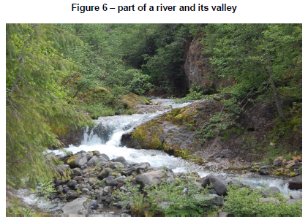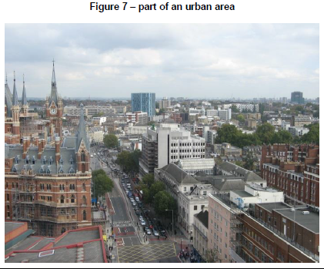
A04.1: Identify two data collection techniques that could be used to carry out a geographical fieldwork investigation in one of the areas shown. (2 marks)
Area chosen:
Technique 1:
Technique 2:

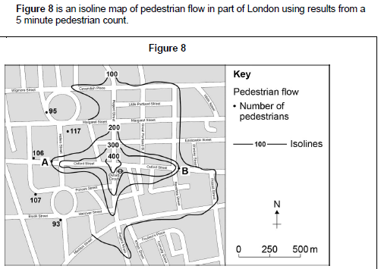
A04.2: Complete the isoline for 100 pedestrians shown on Figure 8. (1 mark)
A04.3: Describe the pattern of pedestrian flow shown on the completed map. (2 marks)

A04.4: Suggest one alternative method of presenting the information shown on Figure 8. (1 marks)

A04.5: Explain why the pattern of pedestrian flow shown in Figure 8 may not be accurate. (2 marks)
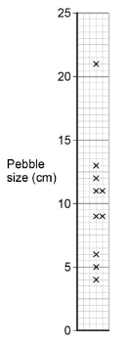
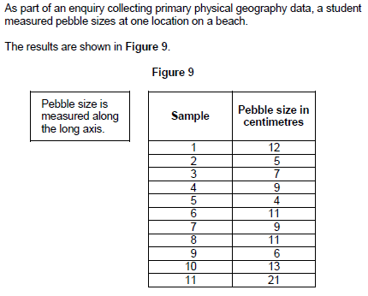
A04.6: Complete the dispersion graph using the data for Sample 3 in Figure 9. (1 mark)
A04.7: Suggest one way in which the data collection technique in Figure 9 could be adapted to make the sample more reliable. (1 mark)
A04.8: Using the data in Figure 9, calculate the interquartile range of the pebble size data.
Show your working in the space below. (2 marks)
A04.9 Describe the pebble size data shown on the dispersion graph in Question 04.6. (4 marks)

Paper 3: Question 4: Fieldwork skills
Specimen paper B
Study Figure 4, which shows the results of a survey carried out with visitors in
Windermere, in the Lake District. One hundred people were interviewed.
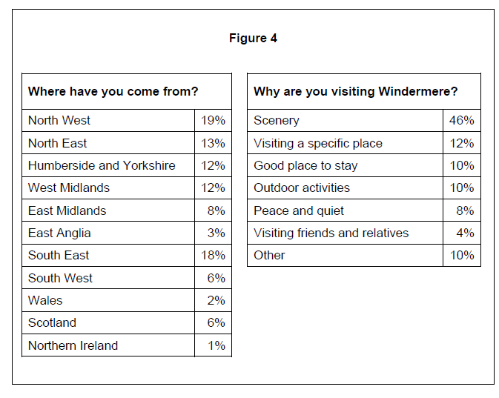
B4.1 Complete the map below to show the origin of visitors to Windermere from: [2 marks]
South East 18%
Wales 2%

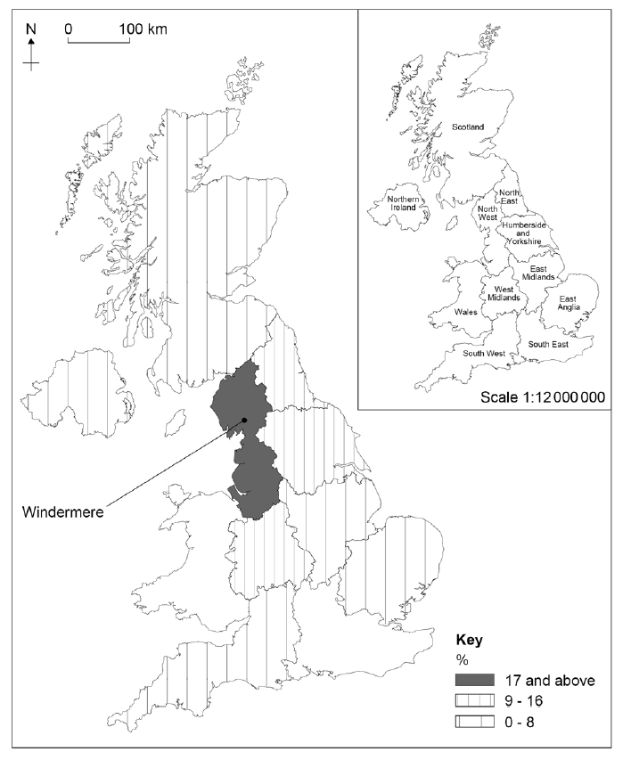

B4.2 Suggest one reason why each of the following questions might be useful for an
enquiry about visitors to Windermere. [2 marks]
Where have you come from?
Why are you visiting Windermere?

B4.3 Study Figure 5, two sets of data collected by students who were carrying out a geographical enquiry about traffic problems in a town centre.
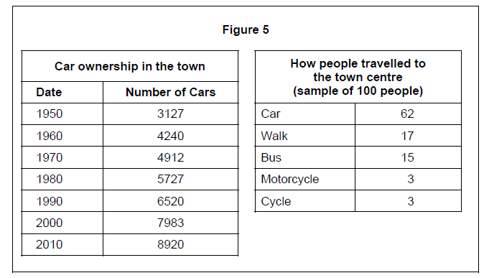

B4.3 The following four methods were considered for presenting the data shown in Figure 5.
A Pie chart
B Line graph
C Proportional symbol map
D Flow line map
Which method (A, B, C or D) would be most suitable for presenting each set of data?
[2 marks]
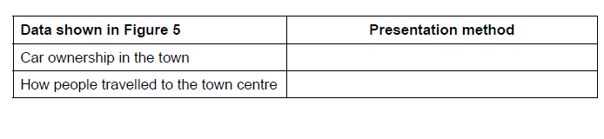
B4.4 Study Figure 6 which shows the results of a Car Park Survey.
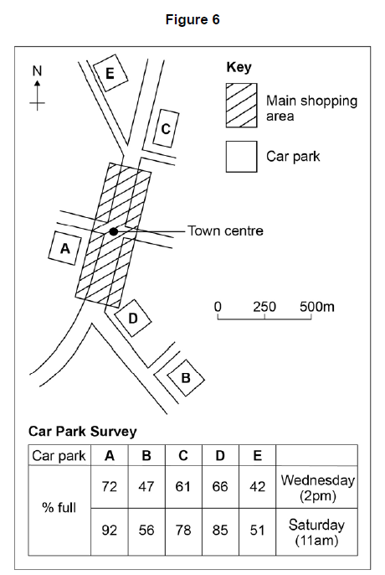

B4.4 Suggest reasons for the differences shown in the Car Park Survey between Wednesday and Saturday. [4 marks]
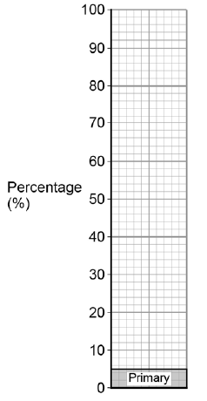
Study Figure 7, data collected by means of a questionnaire about the employment structure of a town.

B4.5 Complete the divided bar graph below by plotting the data shown in Figure 7.
[1 mark]
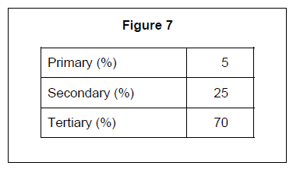

B4.6 Suggest one other method that could be used to present the employment structure
data. [1 mark]

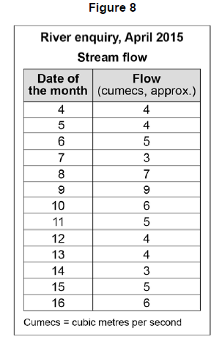
Study Figure 8, data collected for a river enquiry.
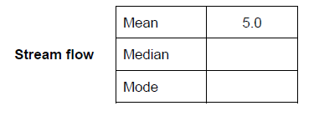
B4.7 Complete the following table by using the stream flow data in Figure 8. [2 marks]

B4.8 Suggest two pieces of advice that should be given to students in order to reduce
potential risks when carrying out a physical geography enquiry. [2 marks]
1

2

Paper 3: Question 4: Fieldwork skills
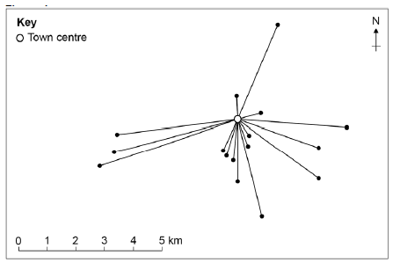
Specimen paper C

Study Figure 4, a map showing the movement of individual people from their homes
to a town centre.

C4.1 Name the type of map used in Figure 4. Shade one circle only. [1 mark]
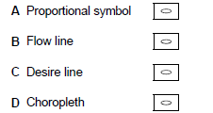

C4.2 Plot the following information on Figure 4. A person travelled 2.5 km from the south-west. [2 marks]

C4.3 Describe the pattern shown on Figure 4. [2 marks]

C4.4 Suggest two additional pieces of information that could be added to Figure 4 to explain the pattern of movement. [2 marks]

1

2

C Study Figure 5, a table used by students to carry out a noise pollution survey.
Figure 5
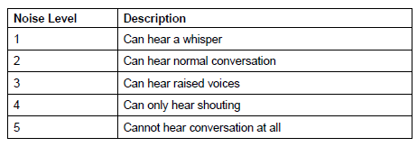

C4.5 Suggest one advantage and one disadvantage of using the noise pollution table
shown in Figure 5. [2 marks]

Advantage

Disadvantage

C Study Figure 6, a diagram showing how a student presented the noise pollution survey
data.
Figure 6

C4.6 Suggest a more appropriate way of presenting the noise pollution data shown in
Figure 6. [2 marks] Give one reason for your choice.

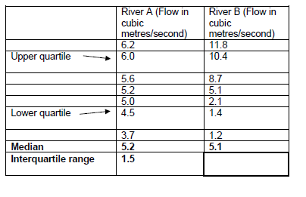
C Students measured the flow of water in two different rivers over 7 days. Figure 7
shows the results, in rank order, for the two rivers.
Figure 7

C4.7 Complete the table (Figure 7) by calculating the interquartile range for River B. [1 mark]

C4.8 Suggest why median and interquartile values are useful when comparing data such as
that shown in Figure 7. [4 marks]

2019
Study Figure 4, a table showing information collected by students about housing
development in four areas on the edge of a town.
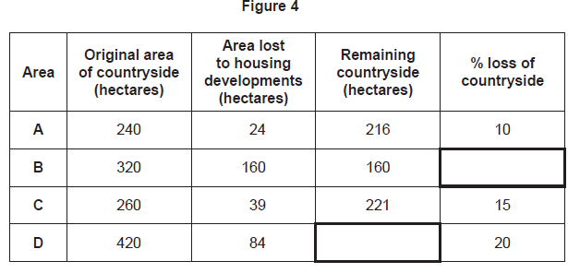
4.1 Complete the table (Figure 4) by filling in the data for Area B and Area D. [2 marks]

Study Figure 5, showing information from a survey of 100 people in a coastal area.
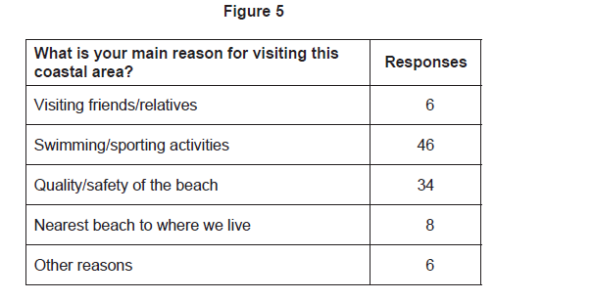
0.42 Complete the pie chart below to show the information for Figure 5. [1 mark]
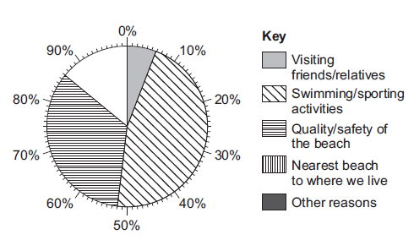

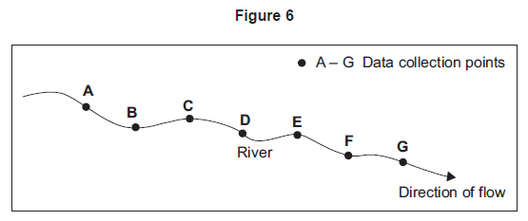
4.4 Name the type of sampling method used in Figure 6. Circle one letter only. [1 mark]

A Opportunity sampling, selecting points which are easiest to access
B Random sampling, based on chance
C Stratified sampling, where more points are chosen from one area
D Systematic sampling where points are chosen at regular intervals

4.5 Suggest why the type of sampling shown in Figure 6 is not always possible in a fieldwork enquiry. [2 marks]

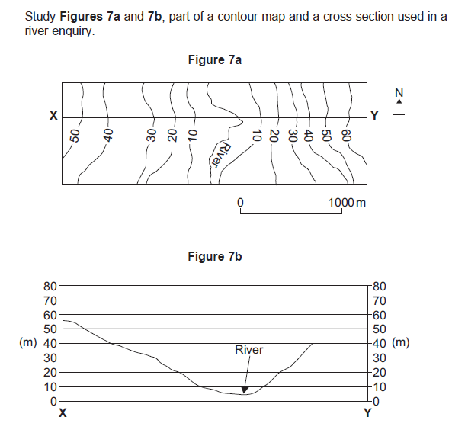

4.5 Complete the cross-section from X–Y on Figure 7b. [1 mark]

4.6 Describe the slope of the land from point X to the river. [1 mark]

Study Figure 8, information about a questionnaire survey.
Figure 8
A group of students used a questionnaire to assess whether local facilities for the older population were good enough.

In this area 48% of the population are over 50 years old. Females account for 56% of this age group.

The students completed the questionnaire in the town centre on a Saturday morning.

The following diagram shows the age groups of people who were asked to complete the questionnaire.
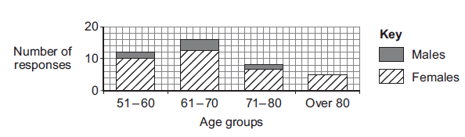
4.7 Suggest two ways that students might adapt their method in order to obtain more
appropriate data. [2 marks]
1.
2.

4.8 Suggest two additional data collection techniques that the students could use to find
out if local facilities are good enough for the older population. [2 marks]
1.
3.

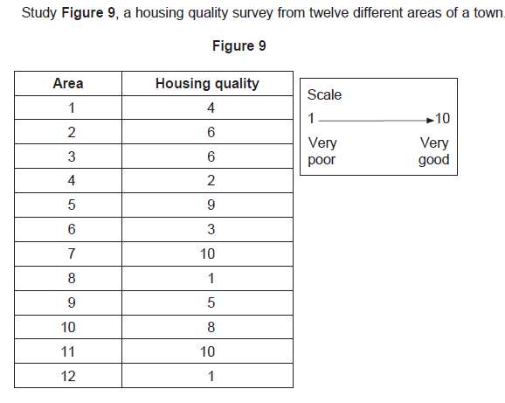
4.9 Assess the usefulness of measures of central tendency, such as median, mean and mode, in analysing the housing quality data collected by the students. [4 marks]

Paper 3: Question 4: Fieldwork skills
2018 paper

Study Figure 4, information collected by students about visitors to Bournemouth, a coastal town in Dorset.
Figure 4
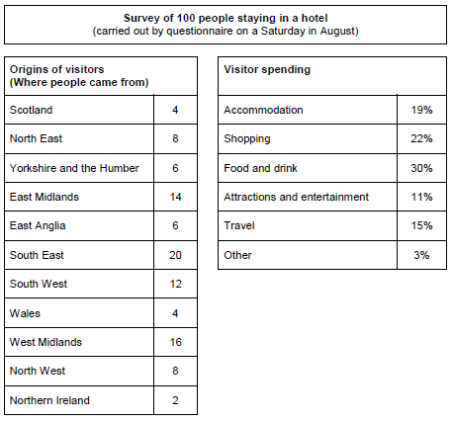

2018 4.1
Complete the map below (Figure 5) to show the origin of visitors to Bournemouth using the following data.

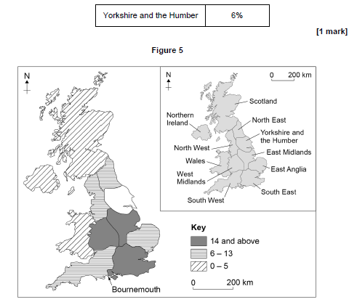

2018 4.2 Describe the pattern shown by Figure 5. [2 marks]

2018 4.3 (a) Suggest one additional question which could be included on the visitor survey. [1 mark]

(b) Give one reason why your chosen question might provide useful information for the visitor survey. [1 mark]

2018 Study Figure 6, information about visitor numbers to the main tourist attractions in a city.
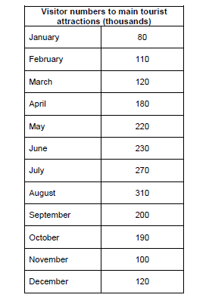
Figure 6

2018 A student used the following presentation method (Figure 7) to show the information in Figure 6.
Figure 7
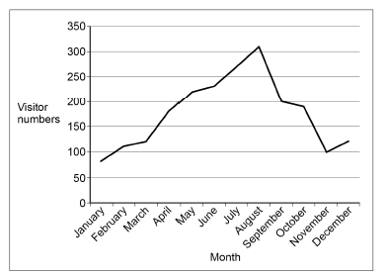

2018 4.4 a) Suggest a more appropriate method for presenting the data shown in Figure 6. [1 mark]

- Give a reason for your choice. [1 mark]

2018 As part of a geographical enquiry, students carried out an environmental quality survey in one part of a town centre. The results are shown in Figure 8.
Figure 8

2018 4.5 What is the total environmental quality score for the area shown in Figure 8? [1 mark]
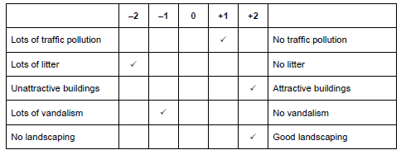

2018 4.6 Suggest one advantage and one disadvantage of using the technique shown in
Figure 8 to measure environmental quality. [2 marks]

Advantage

Disadvantage

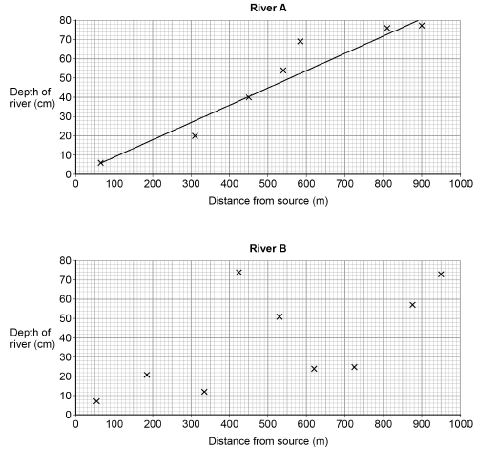
Students studied two different rivers over a distance of 1000 metres. For each river they measured the depth at a number of sites. The results are shown on Figure 9.

2018 4.7 Complete the scattergraph for River B by plotting the following data. [1 mark]

Distance from source – 450 m
Depth of river – 22 cm

2018 4.8 Draw a line of best fit on the scattergraph for River B. [1 mark]

2018 4.9 Compare the relationship between distance from source and depth of river for the two rivers.
[4 marks]

November 2020: Paper 3
A student wanted to carry out a human geography enquiry in their local town by investigating the question ‘Does the town centre have a parking problem?’
In order to do this the student carried out primary research, including a questionnaire
and a car park survey.
Study Figure 4, which shows the results of the questionnaire and car park survey.

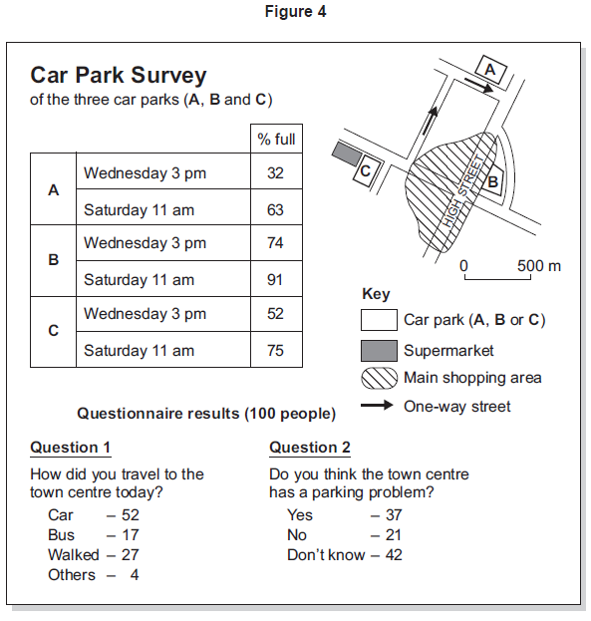

2020 0 4 . 1 Complete the pie chart below to show the results of Question 2 in the questionnaire
(Figure 4). [1 mark]
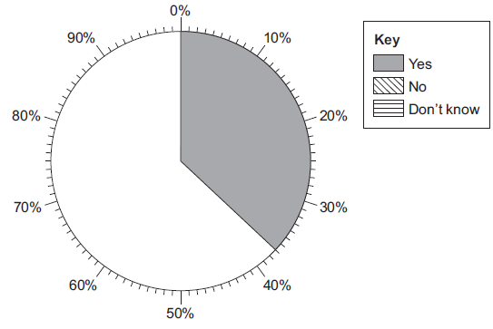

2020 0 4 . 2 Using Figure 4, describe the pattern shown by the results of the car park survey. [2 marks]
___________________________________________________________________________________
___________________________________________________________________________________
___________________________________________________________________________________
___________________________________________________________________________________

2020 0 4 . 3 To what extent can the student draw reliable conclusions from the data? [4 marks]
___________________________________________________________________________________
___________________________________________________________________________________
___________________________________________________________________________________
___________________________________________________________________________________
___________________________________________________________________________________
___________________________________________________________________________________
___________________________________________________________________________________
___________________________________________________________________________________
Extra space ______________________________________________________________________
___________________________________________________________________________________
___________________________________________________________________________________
___________________________________________________________________________________

A group of students wanted to investigate the hypothesis that ‘The size of pebbles in a river is smaller as the river flows downstream’.
In order to do this the students measured the long axis of ten pebbles from three different places (A, B and C) along the river.
Study Figure 5, a table showing the results of the survey.

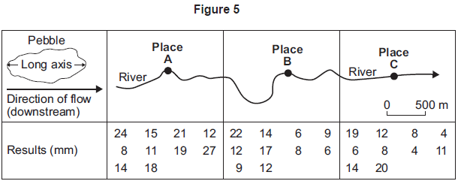

2020 0 4 . 4 Complete the diagram below by filling in the median pebble size for place C. [1 mark]
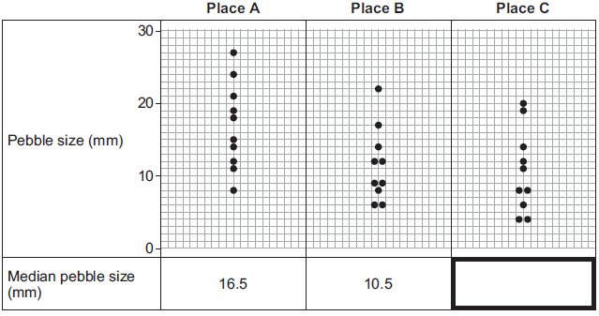

2020 0 4 . 5 Outline the conclusions that the students could draw from the data. [2 marks]
___________________________________________________________________________________
___________________________________________________________________________________
___________________________________________________________________________________
___________________________________________________________________________________

2020 0 4 . 6 Suggest two ways that the data collection method could be adapted in order to
make it more useful. [2 marks]
1 _________________________________________________________________________________
___________________________________________________________________________________
2 _________________________________________________________________________________
___________________________________________________________________________________

A student wanted to investigate deprivation in an area of a city. As part of their enquiry they used the following secondary data (Figure 6).
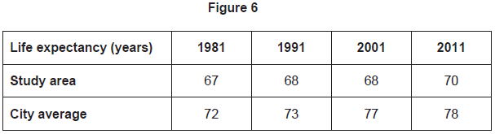

2020 0 4 . 7 Complete the graph below to show life expectancy in the study area. [1 mark]

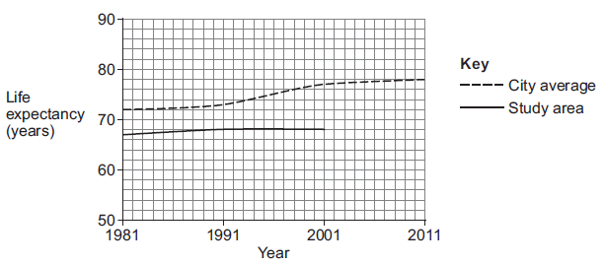

2020 0 4 . 8 In 2001, how many years lower was life expectancy in the study area than the city
average? [1 mark]
___________________________________

2020 0 4 . 9 Suggest two types of primary data that the student could use in their urban
deprivation enquiry. [2 marks]
1 _________________________________________________________________________________
___________________________________________________________________________________
2 _________________________________________________________________________________
___________________________________________________________________________________

